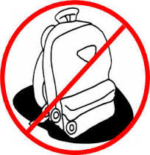

**Join my Remind group!**

ELA: Text **@b78fb6**

SS: Text@ **k7ae43**

**To 81010**

**Classroom Rules:**

**#1 Follow Directions the First Time**

**#2 Keep Hands, Feet, and Objects to yourself**

**#3 Respect each other and your teacher**

“Do-Overs”

Any assignment may be

resubmitted ONCE in an attempt to improve original grade.

(Adequate preparation required.)

**Every Day** You Must Have:

* **Paper**
* **Pencil or pen**
* **1.5 inch binder**
* **7th grade folder (school issued)**

**Grade Weights…**

**Formative 60%**

**(classwork, quizzes, etc.)**

**Summative 40%**

**(tests, projects, etc.)**

ELA &

World Studies

Mrs. Hartung

lisahartung@pickenscountyschools.org